**Title: Why Invest in Uganda?**

## **Slide 1: Brief Introduction: DIMS.**

* What are DIMS?

**Slide 2: Uganda at a Glance.**

* **Population:** 45.6 million (UBOS, 2024).
* **GDP Growth Rate:** 7% projection in 2025/2026, (Ministry of Finance 2024).
* **Inflation Rate:** 3.2%, indicating macroeconomic stability despite global inflationary pressures, attributed to services and industry sectors, promoting consumer demand and FDI (Ministry of Finance, 2024).
* **Ease of Doing Business Ranking:** Among the best in East Africa (World Bank), 12th in Africa, (Daily Monitor, 2021).
* **Total FDI Investment Value:** $3,034.11 million attributed towards the oil and gas sector. Diaspora Remittances at $1.29 billion (Ministry of Finance, 2024).
* Total DID Investment Value:

**Slide 3: Key Priority Sectors; NDPIV at a Glance.**

*Source: (NDPIV, 2025-2030)*

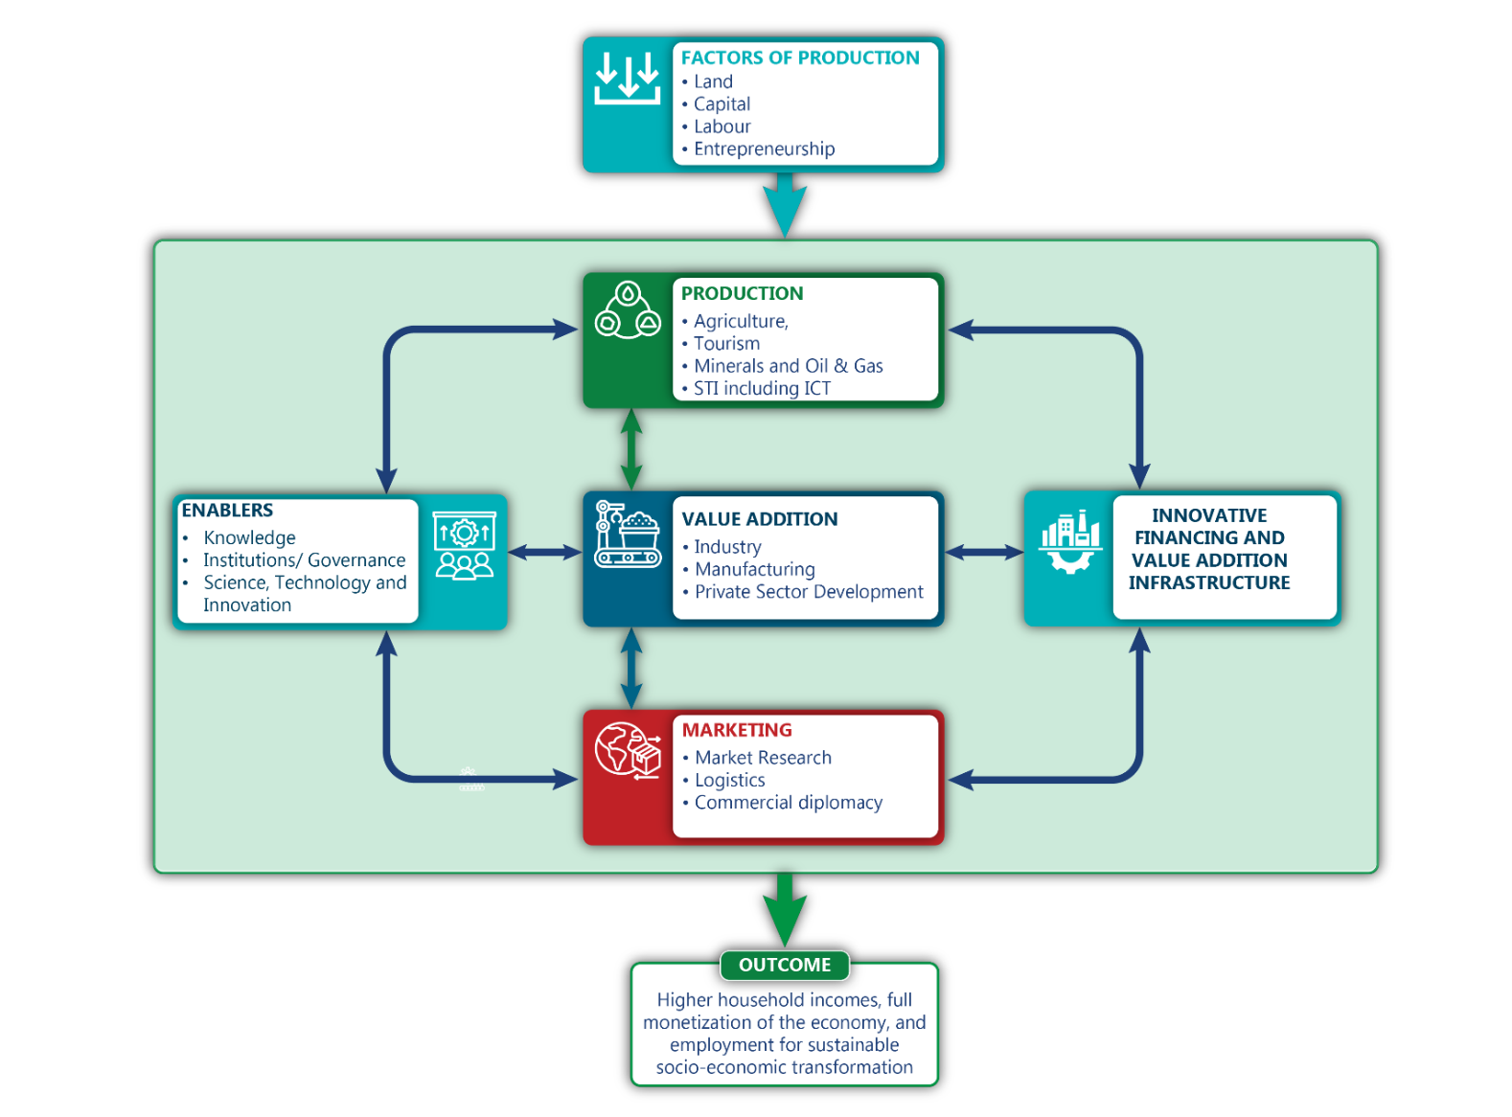

## **Slide 4: Uganda’s Investment Climate.**

* **Location:**
  + Uganda serves as a regional hub in East and Central Africa, offering access to over 400 million consumers.
  + Key member of EAC, COMESA, and AfCFTA, providing tariff-free trade benefits.
* **Robust Economic Growth:**
  + Uganda’s economy has demonstrated resilience and growth, with a GDP increase of 5.3% in 2023, supported by strong agricultural and industrial performance.
  + A growing middle class and increasing consumer demand create new investment opportunities.
* **Political Stability & Governance:**
  + Over 35 years of stable governance have fostered a predictable business environment.
  + Uganda is committed to investor-friendly policies and legal reforms to attract FDI.
* **Open Market Policies & Investment Protection:**
  + No restrictions on profit repatriation, allowing investors to freely transfer funds.
  + Uganda is a member of multiple trade agreements, including EAC, COMESA, and AfCFTA, providing access to regional and international markets.
  + Strong legal frameworks in place to protect investor rights and ensure fair competition.
* **Competitive Labor Market & Skilled Workforce:**
  + Over 70% of Uganda’s population is under 30, providing a dynamic and youthful workforce.
  + Government initiatives focus on enhancing vocational skills to support industrial and technological advancements.
* **Government Incentives & Investor Support:**
  + Attractive tax incentives, including tax holidays and VAT exemptions for key industries.
  + Special Economic Zones (SEZs) and industrial parks provide cost-effective infrastructure and regulatory ease.
  + Uganda Investment Authority (UIA) operates a one-stop center for investors, streamlining business registration and post-investment support.
* **Infrastructure:**
  + **25 Industrial Parks** across Uganda with dedicated utilities and logistics.
  + **Modern Transport & Logistics Network:** Upgraded Road networks connecting industrial hubs to regional and global markets.  
    Standard Gauge Railway (SGR) under development for improved cargo transport.  
    Expansion of Entebbe International Airport to facilitate increased trade volume.
  + **Energy Infrastructure:**Over 1,500 MW of electricity generation capacity, with ongoing hydro and solar projects. Government investment in stable power supply for industrial growth.
  + **Special Economic Zones (SEZs):**Investment-ready zones offering tax breaks, customs incentives, and trade facilitation.
* **Skilled & Young Workforce:**
  + Over 70% of Uganda’s population is under 30, providing a dynamic labor force.
  + Government initiatives to enhance vocational and technical skills to meet industrial demands.

## **Slide 5: DIMS Scope.**

## **Slide 6: The Role of Digital Investment Management System (DIMS)**

* **Seamless Investment Licensing & Processing:**
  + DIMS provides an online platform for investors to apply for and track investment licenses.
  + Reduces bureaucratic delays by integrating multiple approval agencies in one system- less than 24 hours to issue investment licenses.
* **Market Intelligence & Investment Data:**
  + Access to real-time market trends, sector-specific opportunities, and economic indicators.
  + Helps investors make informed decisions based on credible data from World Bank, UIA, and BoU.
* **Investor Aftercare & Support Services:**
  + Ensures post-investment support, including resolving operational challenges.
  + Offers dedicated assistance for compliance with tax policies and investment regulations.
* **AI-Driven Decision Making & Predictive Analytics:**
  + Uses data analytics and AI to provide insights on investment trends and risks.
  + Enhances efficiency in policy formulation and investor engagement.
* **Integration with Government and Private Sector:**
  + Connects investors with key stakeholders such as ministries, UIA, and financial institutions.
  + Promotes Public-Private Partnerships (PPPs) for large-scale investments.

**Slide 8: Impact of DIMS on Investment/ Key Objectives- On ppt..**

## **Slide 9: Branding- On PPT**

## **Slide 10: Summary Modules and Conclusion.**

* **Summary of Key DIMS Impact**
* **Conclusion**